**Sample Swim Shirt and logo**

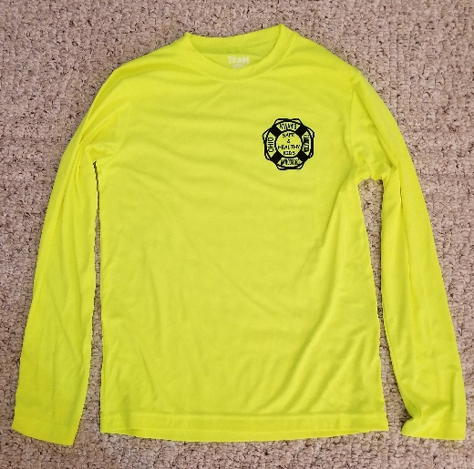

**Bright Yellow**

**New Colors Available**

**Blue Golden Yellow Grey**

**Purple Red**