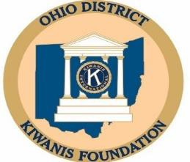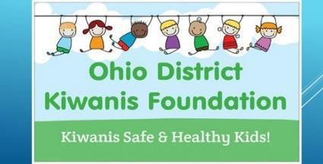

Applications for Mini Matching Grants Date Rec’d
(For requests of $500.00 or less) Date Forw’d

Mini Matching Grant Application Deadlines for grant submission are October 31st, December 31st, February 28th, April 30th, June 30th, and August 31st
SEND TO OHIO KIWANIS FOUNDATION PO. BOX 668 Circleville, Ohio 43113
Or email to: grants@odkf.org

Sponsor Kiwanis Club Address Contact Persons Name Contact Persons Title Phone # Organization Name
Is this organization tax-exempt Tax Number Attach Tax-exempt letter Verified Project Title and Brief Description

Individual Group to be Benefited Total Project Cost Size of Group How Much Is the Sponsor Kiwanis Club Contributing to the Project Amount requested from Foundation. (up to $500.00 in matching grant) Club President: Date Signature Date

Recommendation from Foundation Board: Date Approved: Amount Date Signature Date

